

Economics

SAC 2.1 UNIT 3 OUTCOME 2

5th April 2022 Period 5
You will have 60 minutes to complete this task plus 5 minutes reading time

Teacher: Mr. Daniel Charles & Ms Sarah Hubbard

The total SAC contributes to 30/100 of SAC marks allocated for Unit 3.

Allowed materials for this task include:
- Pens, pencils, rulers, erasers, highlighters

Name ______________________________________

Note: The grade or score for this task is only part of the internal assessment for this Unit. Your total School-assessed Coursework score may change as a result of statistical moderation by VCAA.

Grade/Score: ______ Satisfactory Completion? S/N: ______
(Provisional)
VCE ECONOMICS
SCHOOL-ASSESSED COURSEWORK
Performance Descriptors
Unit 3  Outcome 2  Analyse key contemporary factors that may have influenced the Australian Government’s domestic macroeconomic goals over the past two years and discuss how achievement of these goals may affect living standards. | DESCRIPTOR: typical performance in each range
 | Very low | Low | Medium | High | Very high
 | The analysis lacks clarity and demonstrates limited knowledge of how key contemporary factors may have influenced the Australian Government’s domestic macroeconomic goals over the past two years. | Superficial analysis with some factors identified which demonstrates some knowledge of how key contemporary factors may have influenced the Australian Government’s domestic macroeconomic goals over the past two years. | Satisfactory analysis which generally demonstrates adequate knowledge of some of the contemporary factors that may have influenced the Australian Government’s domestic macroeconomic goals over the past two years. | Generally thorough analysis of some of key contemporary factors that may have influenced the Australian Government’s domestic macroeconomic goals over the past two years. | Comprehensive and detailed analysis of a range of key contemporary factors that may have influenced the Australian Government’s domestic macroeconomic goals over the past two years.
 | The discussion demonstrates limited knowledge of how achievement of the Australian Government’s domestic macroeconomic goals might affect living standards. | Some elementary discussion of how achievement of the Australian Government’s macroeconomic goals might affect living standards. | Satisfactory discussion of how achievement of the Australian Government’s domestic macroeconomic goals might affect living standards. | Generally well developed and mostly relevant discussion of how achievement of the Australian Government’s domestic macroeconomic goals might affect living standards. | Very thorough and logical discussion of how achievement of the Australian Government’s domestic macroeconomic goals might affect living standards.
 | Limited use and application of economics terms, concepts, theories and data in the analysis and discussion. Little use of relevant data and evidence to support analysis and discussion. | Some accurate application of knowledge and use of specialist economic terms, concepts and theories. Some reference to relevant data and evidence but not always applied appropriately. | Satisfactory selection, use and application of economics terms, concepts, theories, data and evidence to support the analysis and discussion. | Accurate definition, use and application of economics terms, concepts and theories. Sound use of relevant data and evidence to support the analysis and discussion. | Confident and accurate definition, use and application of economics terms, concepts and theories. Sophisticated use of relevant data and evidence to support the analysis and discussion.
 | Very little analysis and understandings of economic relationships. Reasoning and interpretation lacks clarity. Little evidence of an ability to synthesise arguments or draw appropriate conclusions. | Some understanding of economic relationships with some relevant conclusions. Limited use of relevant evidence, synthesis of arguments and logical economic reasoning. | Generally satisfactory analysis of the interrelatedness of economic relationships demonstrating adequate economic reasoning and interpretation. Some ability to synthesise arguments and draw some conclusions. | Generally thorough analysis of the interrelatedness of economic relationships demonstrating sound economic reasoning and interpretation. An ability to synthesise arguments and draw conclusions is mostly well developed | Comprehensive and logical analysis of the interrelatedness of economic relationships demonstrating highly developed skills of economic reasoning and interpretation. Sophisticated ability to synthesise arguments and draw conclusions.

Section A – Multiple Choice Questions (5 marks)

Question 1
The following table indicates the quarterly Consumer Price Index(CPI) outcomes for a hypothetical economy.
 | CPI
June 2020 | 100
September 2020 | 102
December 2020 | 103
March 2021 | 107
June 2021 | 109

With reference to the data in the table, the annual rate of inflation for the year ended June 2021 is
- 2%
- 4%
- 5%
- 9%

Question 2
The war in Ukraine over the early part of 2022 resulted in Australian petrol prices soaring above $2 per litre. This tends to:

A. increase cost inflation and cause the underlying rate of inflation to climb above the headline rate of inflation
B. increase cost inflation and cause the headline rate of inflation to climb above the underlying rate of inflation
C. increase demand inflation and cause the underlying rate of inflation to climb above the headline rate of inflation
D. increase demand inflation and cause the headline rate of inflation to climb above the underlying rate of inflation

Question 3
The Australian economy is currently in the recovery phase of the business cycle. This means that:
A. Economic growth and inflation will be rising while unemployment and incomes are falling
B. Economic growth and inflation will be falling while unemployment and incomes will be rising
C. Economic growth, inflation and income will be rising, while unemployment will be falling
D. Economic growth, inflation, interest rates and unemployment will be rising.

Question 4
Each of the following events is likely to increase living standards, with the exception of:

A. A rise in real GDP per capita
B. A rise in literacy rates
C. A fall in crime rates
D. A rise in mental illness

Question 5
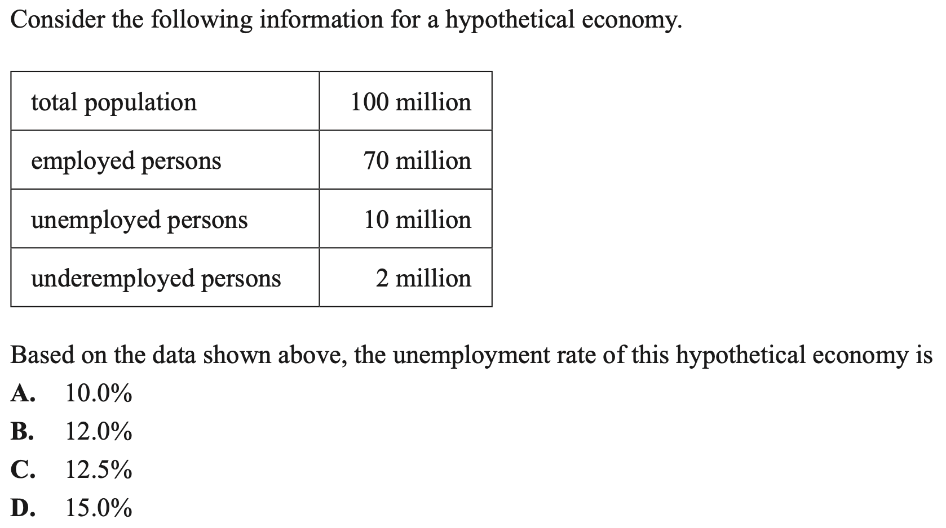
Section B - Short Answer Questions (35 marks)

Question 1 (13 marks)

a. Distinguish between hidden and under (disguised) unemployment.
3 marks
____________________________________________________________________________________________________________________________________________________________________
____________________________________________________________________________________________________________________________________________________________________
____________________________________________________________________________________________________________________________________________________________________
____________________________________________________________________________________________________________________________________________________________________
____________________________________________________________________________________________________________________________________________________________________

b. Outline two types of unemployment that occur in the Australian economy.
2 marks
____________________________________________________________________________________________________________________________________________________________________
____________________________________________________________________________________________________________________________________________________________________
____________________________________________________________________________________________________________________________________________________________________
____________________________________________________________________________________________________________________________________________________________________

c. Identify and explain one factor that has had a positive influence on aggregate demand and the goal of full employment over the last two years.
4 marks
____________________________________________________________________________________________________________________________________________________________________
____________________________________________________________________________________________________________________________________________________________________
____________________________________________________________________________________________________________________________________________________________________
____________________________________________________________________________________________________________________________________________________________________
____________________________________________________________________________________________________________________________________________________________________
____________________________________________________________________________________________________________________________________________________________________
____________________________________________________________________________________________________________________________________________________________________
____________________________________________________________________________________________________________________________________________________________________

Unemployment rate in Australia over the last 12 months

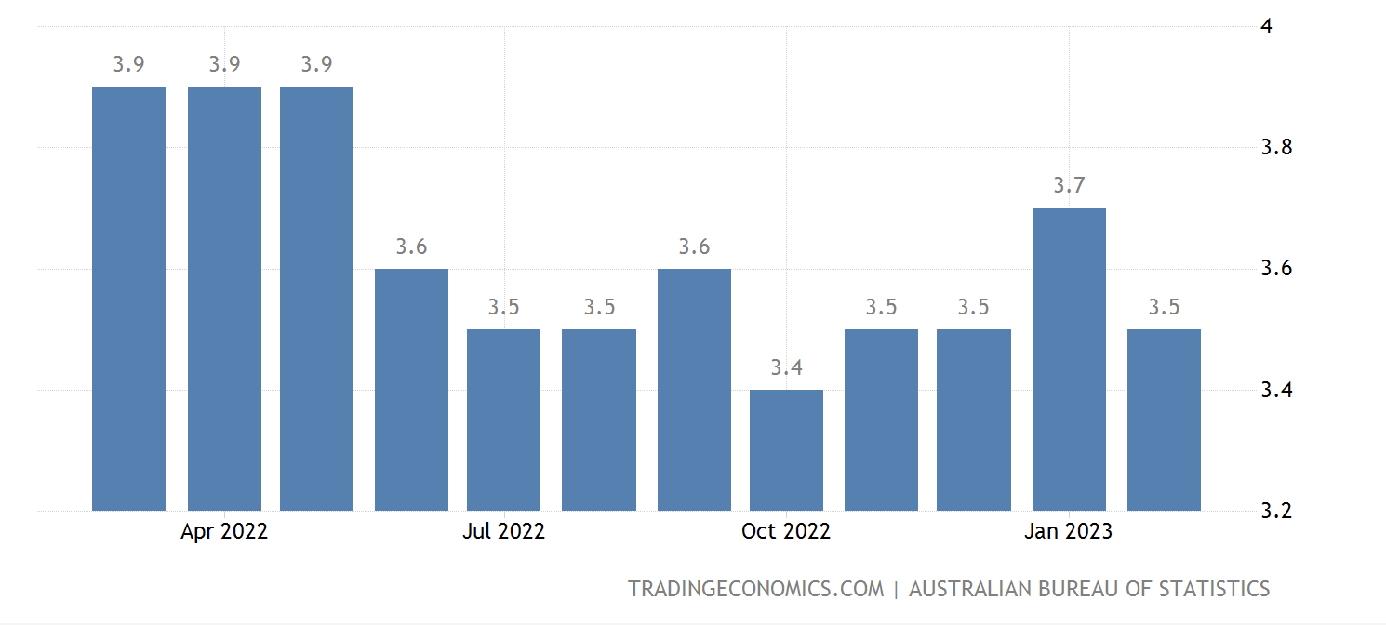

d. Describe the trend in the unemployment rate over the last 12 months and describe the impact this trend would have on material and non-material living standards in Australia.
4 marks
____________________________________________________________________________________________________________________________________________________________________
____________________________________________________________________________________________________________________________________________________________________
____________________________________________________________________________________________________________________________________________________________________
____________________________________________________________________________________________________________________________________________________________________
____________________________________________________________________________________________________________________________________________________________________
____________________________________________________________________________________________________________________________________________________________________
____________________________________________________________________________________________________________________________________________________________________
__________________________________________________________________________________
Question 2 (8 marks)
a. Outline what is meant by the goal of strong and sustainable economic growth and explain two reasons why this goal is pursued by the government.
4 marks
____________________________________________________________________________________________________________________________________________________________________
____________________________________________________________________________________________________________________________________________________________________
____________________________________________________________________________________________________________________________________________________________________
____________________________________________________________________________________________________________________________________________________________________
____________________________________________________________________________________________________________________________________________________________________
____________________________________________________________________________________________________________________________________________________________________
____________________________________________________________________________________________________________________________________________________________________

b. Identify and explain one aggregate supply factor that would have had a positive impact on the goal of strong and sustainable economic growth in Australia over the last two years.
4 marks
____________________________________________________________________________________________________________________________________________________________________
____________________________________________________________________________________________________________________________________________________________________
____________________________________________________________________________________________________________________________________________________________________
____________________________________________________________________________________________________________________________________________________________________
____________________________________________________________________________________________________________________________________________________________________
____________________________________________________________________________________________________________________________________________________________________
____________________________________________________________________________________________________________________________________________________________________
____________________________________________________________________________________________________________________________________________________________________

Question 3 (14 marks)

Australian dollar ($AUD) against the US dollar ($USD)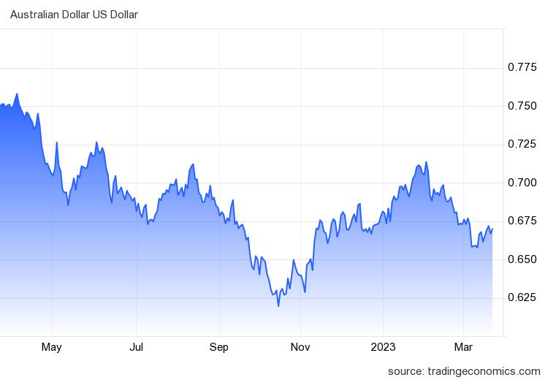
a. Referring to the graph above, analyse how the trend in the exchange rate over the last year would influence the inflation rate in Australia, ceteris paribus.
5 marks
________________________________________________________________________________________________________________________________________________________________________________________________________________________________________________________________________________________________________________________________________
____________________________________________________________________________________________________________________________________________________________________
____________________________________________________________________________________________________________________________________________________________________
____________________________________________________________________________________________________________________________________________________________________
________________________________________________________________________________________________________________________________________________________________________________________________________________________________________________________________________________________________________________________________________
Australian inflation rate April 2020- April 2022
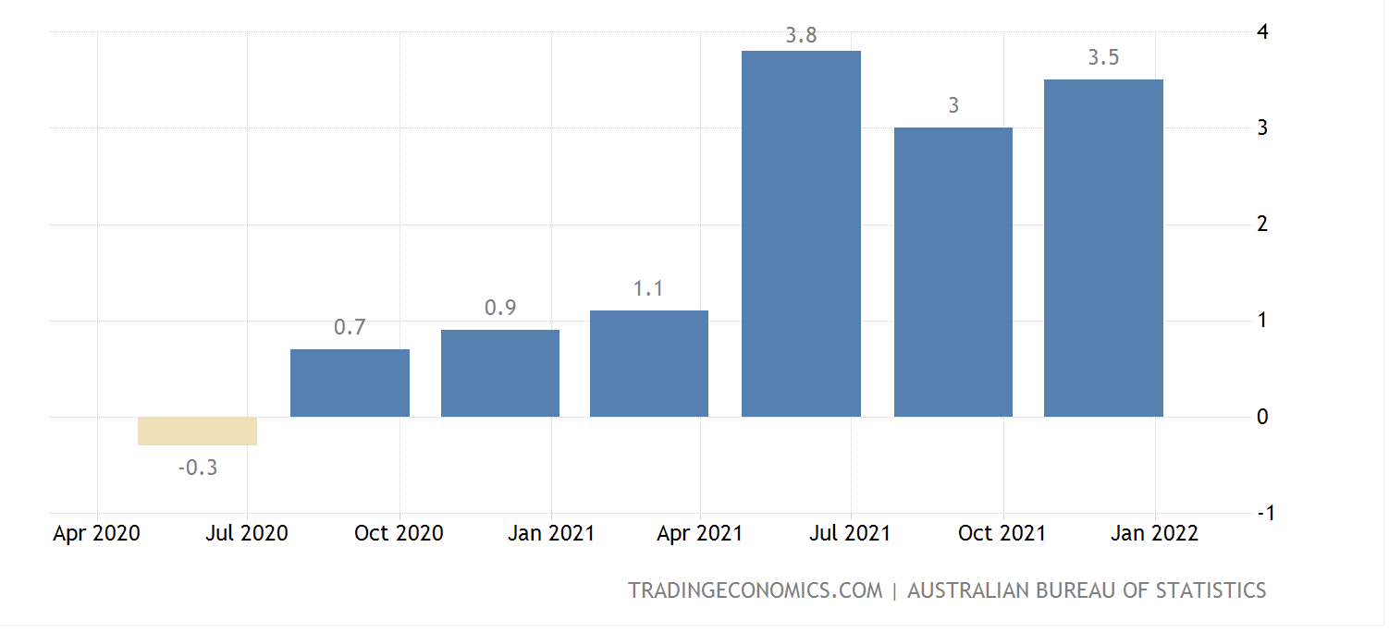
b. Referring to the data above, assess the extent to which the Australian economy has achieved the goal of low inflation over the last two years. (I’m not going to change it because it’s good practice in general)
3 marks
____________________________________________________________________________________________________________________________________________________________________
____________________________________________________________________________________________________________________________________________________________________
____________________________________________________________________________________________________________________________________________________________________
____________________________________________________________________________________________________________________________________________________________________
____________________________________________________________________________________________________________________________________________________________________
____________________________________________________________________________________________________________________________________________________________________

c. Identify and explain one aggregate supply factor that has influenced this trend in the inflation rate over the last 2 years.
2 marks
____________________________________________________________________________________________________________________________________________________________________
____________________________________________________________________________________________________________________________________________________________________
____________________________________________________________________________________________________________________________________________________________________
____________________________________________________________________________________________________________________________________________________________________

Identify and explain two consequences of a high inflation rate for the Australian economy.
4 marks
____________________________________________________________________________________________________________________________________________________________________
____________________________________________________________________________________________________________________________________________________________________
____________________________________________________________________________________________________________________________________________________________________
____________________________________________________________________________________________________________________________________________________________________
____________________________________________________________________________________________________________________________________________________________________
________________________________________________________________________________________________________________________________________________________________________________________________________________________________________________________________________________________________________________________________________
EXTRA WRITING SPACE
________________________________________________________________________________________________________________________________________________________________________________________________________________________________________________________________________________________________________________________________________________________________________________________________________________________________________________________________________________________________________________________________________________________________________________________________________________________________________________________________________________________________________________________________________________________________________________________________________________________________________________________________________________________________________________________________________________________________________________________________________________________________________________________________________________________________________________________________________________________________________________________________________________________________________________________________________________________________________________________________________________________________________________________________________________________________________________________________________________________________________________________________________________________________________________________________________________________________________________________________________________________________________________________________________________________________________________________________________________________________________________________________________________________________________________________________________________________________________________________________________________________________________________________________________________________________________________________________________________________________________________________________________________________________________________________________________________________________________________________________________________________________________________________________________________________________________________________________________________________________________________________________________________________________________________________________________________________________________________________________________________________________________________________________________________________________________________________________________________________________________________________________________________________________________________________________________________________________________________________________________________________________________________________________________________________________________________________________________________________________________________________________________________________________________________________________________________________________________________________________________________________________________________________________________________________________________________________________________________________________________________________________________________________________________________________________________________________________________________________________________________________________________________________________________________________________________________________________________________________________________________________________________________________________________________________________________________________________________________________________________________________________________________________________________________________________________________________________________________________________________________________________________________________________________________________________________________________________________________________________________________________________________________________________________________________________________

